ALFIDO TECH
Customer Behaviour
Analysis

Submitted By: PULLURUJAHNAVI
Date:11-05-2026
Internship organisation: ALFIDO
TECH
Internship Role: Data Analytics
Intern

Executive Summary

This analysis presents a comprehensive Customer Behaviour Analysis.The primary objective is to uncover actionable insights into customer segmentation, purchasing behaviour, retention dynamics, and potential churn risks.
Through rigorous data preprocessing, feature engineering, and advanced analytical techniques such as clustering, customers were categorized into distinct behavioural segments, including Premium Buyers, Dormant Users, and High-Return Customers. These segments provide a structured understanding of varying customer value and engagement levels.
The analysis highlights that high-frequency customers are the primary drivers of revenue, whereas segments characterized by inactivity or frequent returns exhibit a greater likelihood of churn. Additionally, detailed evaluation of purchasing trends across product categories, payment preferences, and temporal (monthly) patterns revealed critical behavioural insights.
Based on these findings, several strategic recommendations are proposed, including the implementation of targeted marketing campaigns, customer loyalty initiatives, personalized product recommendations, and proactive retention strategies. Collectively, these measures are designed to enhance customer engagement, reduce churn, and drive sustainable business growth.

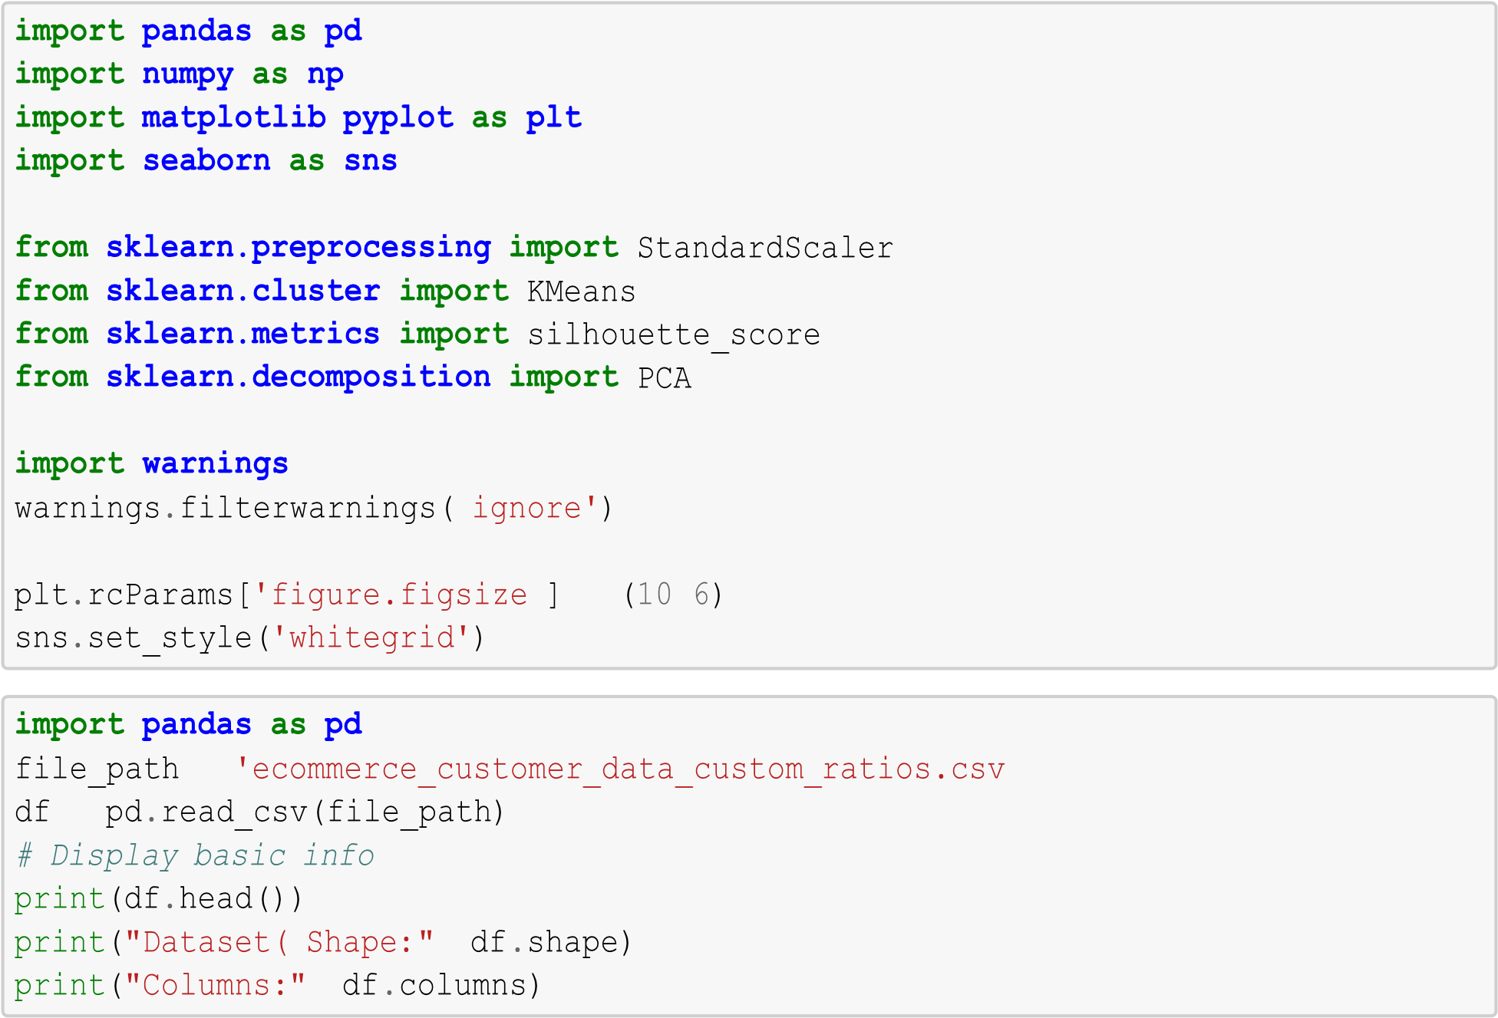
Customer ID Purchase Date Product Category Product Price Quantity \
- 46251 2020-09-08 09:38:32 Electronics 12 3
- 46251 2022-03-05 12:56:35 Home 468 4
- 46251 2022-05-23 18:18:01 Home 288 2
- 46251 2020-11-12 13:13:29 Clothing 196 1
- 13593 2020-11-27 17:55:11 Home 449 1
Total Purchase Amount Payment Method Customer Age Returns \
0 740 Credit Card 37 0.0 1 2739 PayPal 37 0.0
- 3196 PayPal 37 0.0
- 3509 PayPal 37 0.0
- 3452 Credit Card 49 0.0
Customer Name Age Gender Churn
0 Christine Hernandez 37 Male | 0
1 Christine Hernandez 37 Male | 0
2 Christine Hernandez 37 Male | 0
3 Christine Hernandez 37 Male | 0
4 James Grant 49 Female | 1
Dataset( Shape: (250000, 13)
Columns: Index(['Customer ID', 'Purchase Date', 'Product Category', 'Product Price',
'Quantity', 'Total Purchase Amount', 'Payment Method', 'Customer Age',
'Returns', 'Customer Name', 'Age', 'Gender', 'Churn'], dtype='object')
print('Duplicate Rows:', df.duplicated().sum()) df.drop_duplicates(inplace=True) print('Missing Values:') print(df.isnull().sum()) if 'Returns' in df.columns:
df['Returns'] = df['Returns'].fillna(0)
df['Purchase Date'] = pd.to_datetime(df['Purchase Date']) df = df[df['Total Purchase Amount'] > 0] df = df[df['Quantity'] > 0] print('Cleaned Dataset Shape:', df.shape)
Duplicate Rows: 0 Missing Values:
Customer ID 0 Purchase Date 0
Product Category 0
Product Price 0
Quantity 0
Total Purchase Amount 0
Payment Method 0
Customer Age 0 Returns 47596 Customer Name 0
Age 0
Gender 0
Churn 0
dtype: int64
Cleaned Dataset Shape: (250000, 13)
customer_spend = df.groupby('Customer ID')['Total Purchase Amount'].sum().
↪reset_index() customer_spend.columns = ['Customer ID', 'Total_Spend'] purchase_frequency = df.groupby('Customer ID')['Purchase Date'].count().
↪reset_index() purchase_frequency.columns = ['Customer ID', 'Frequency'] latest_date = df['Purchase Date'].max() recency = df.groupby('Customer ID')['Purchase Date'].max().reset_index() recency['Recency'] = (latest_date - recency['Purchase Date']).dt.days recency.drop('Purchase Date', axis=1, inplace=True) basket = df.groupby('Customer
ID')['Quantity'].mean().reset_index() basket.columns = ['Customer ID', 'Avg_Basket_Size'] returns = df.groupby('Customer ID')['Returns'].mean().reset_index() returns.columns = ['Customer ID', 'Return_Ratio'] churn = df.groupby('Customer ID')['Churn'].max().reset_index() cust_data = customer_spend.merge(purchase_frequency, on='Customer ID') cust_data = cust_data.merge(recency, on='Customer ID') cust_data = cust_data.merge(basket, on='Customer ID') cust_data = cust_data.merge(returns, on='Customer ID') cust_data = cust_data.merge(churn, on='Customer ID') print(cust_data.head())
Customer ID Total_Spend Frequency Recency Avg_Basket_Size \
- 1 3491 1 57 5.000000
- 2 7988 3 298 2.666667
- 3 22587 8 88 2.875000
- 4 8715 4 126 2.250000
- 5 12524 8 170 4.125000
Return_Ratio Churn
- 1.000000 0 1
0.333333 0 2
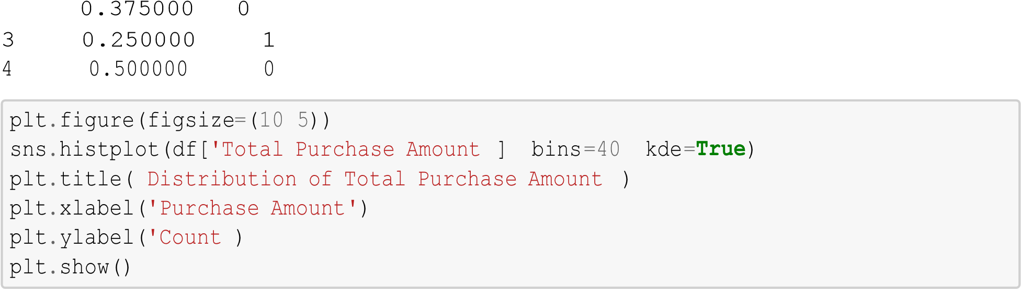
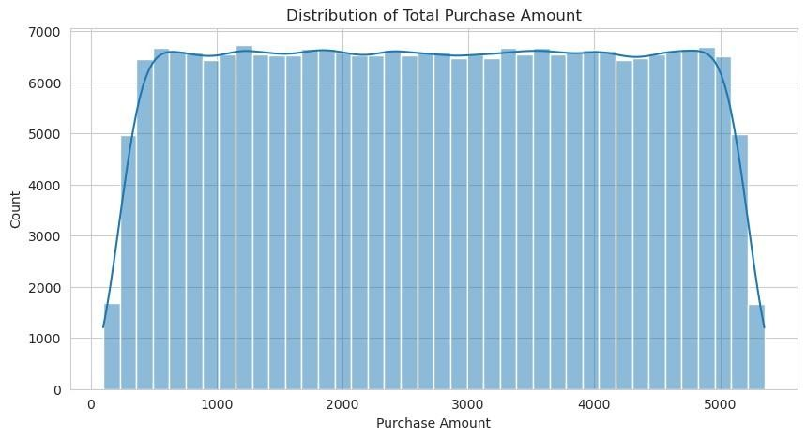
category_sales = df.groupby('Product Category')['Total Purchase
Amount'
]
.
sum()
.

↪
sort_values(ascending
=
False
)

category_sales
.
plot(kind
=
'bar'
)

plt
.
title(
'Sales by Product Category'
)

plt
.
ylabel(
'Revenue'
)

plt
.
show()

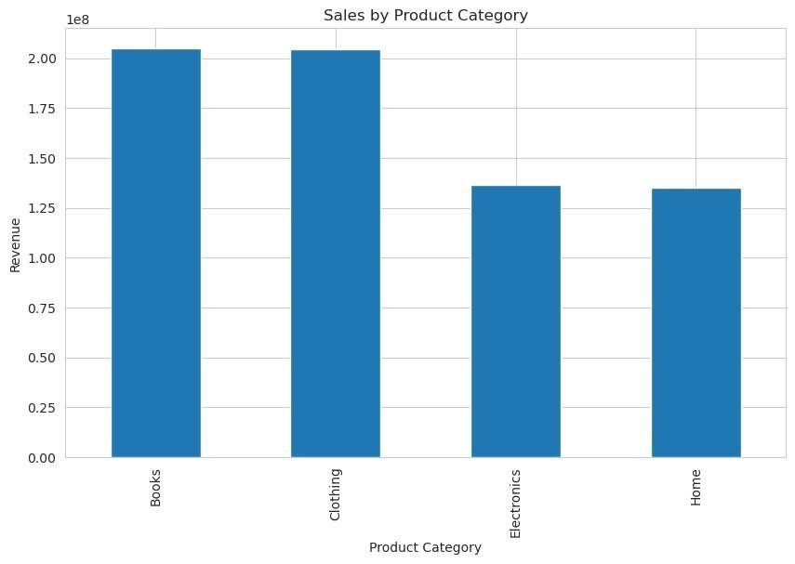
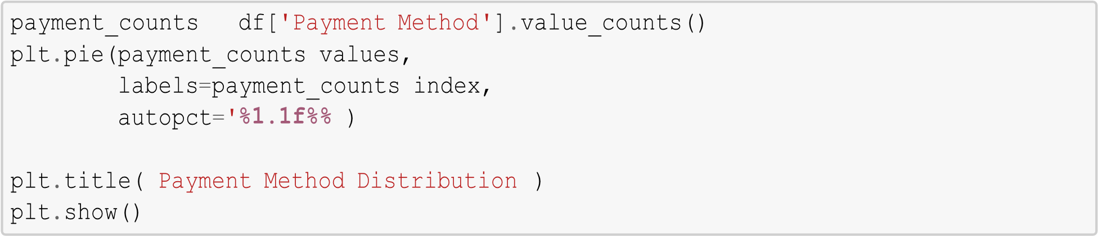
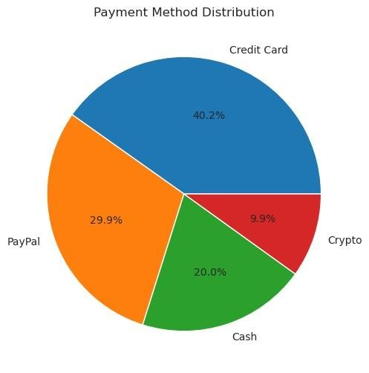
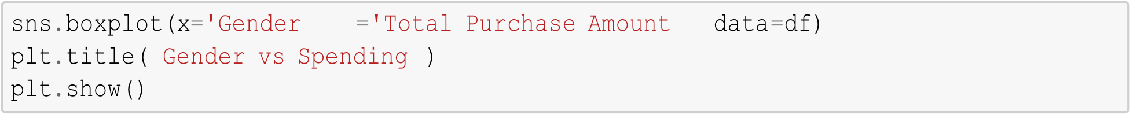
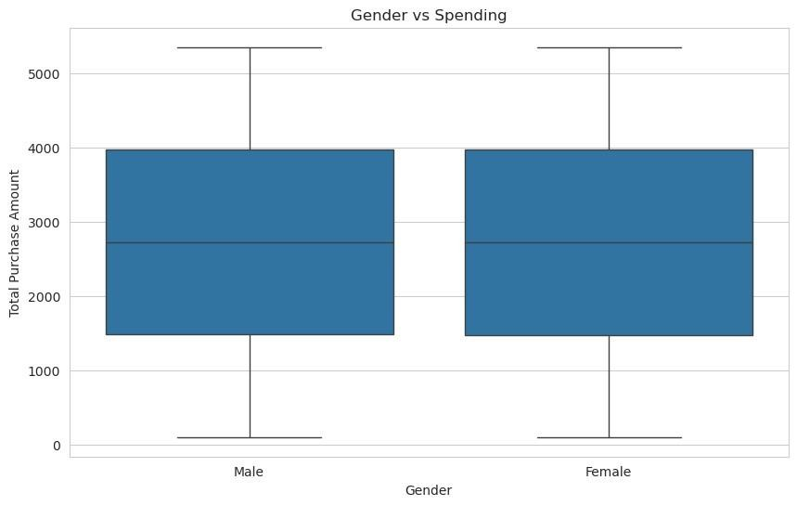
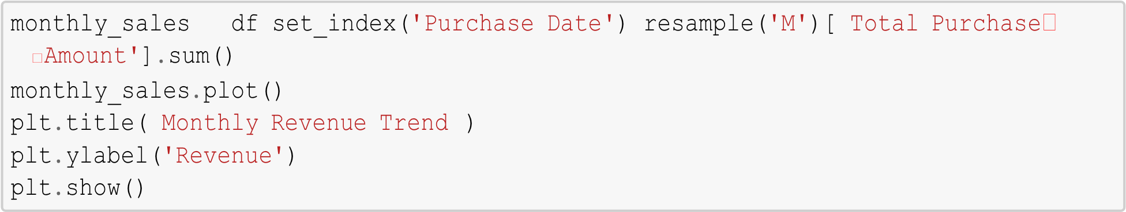
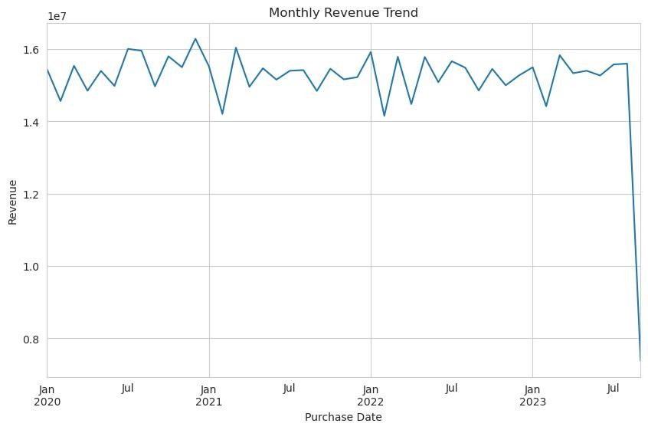
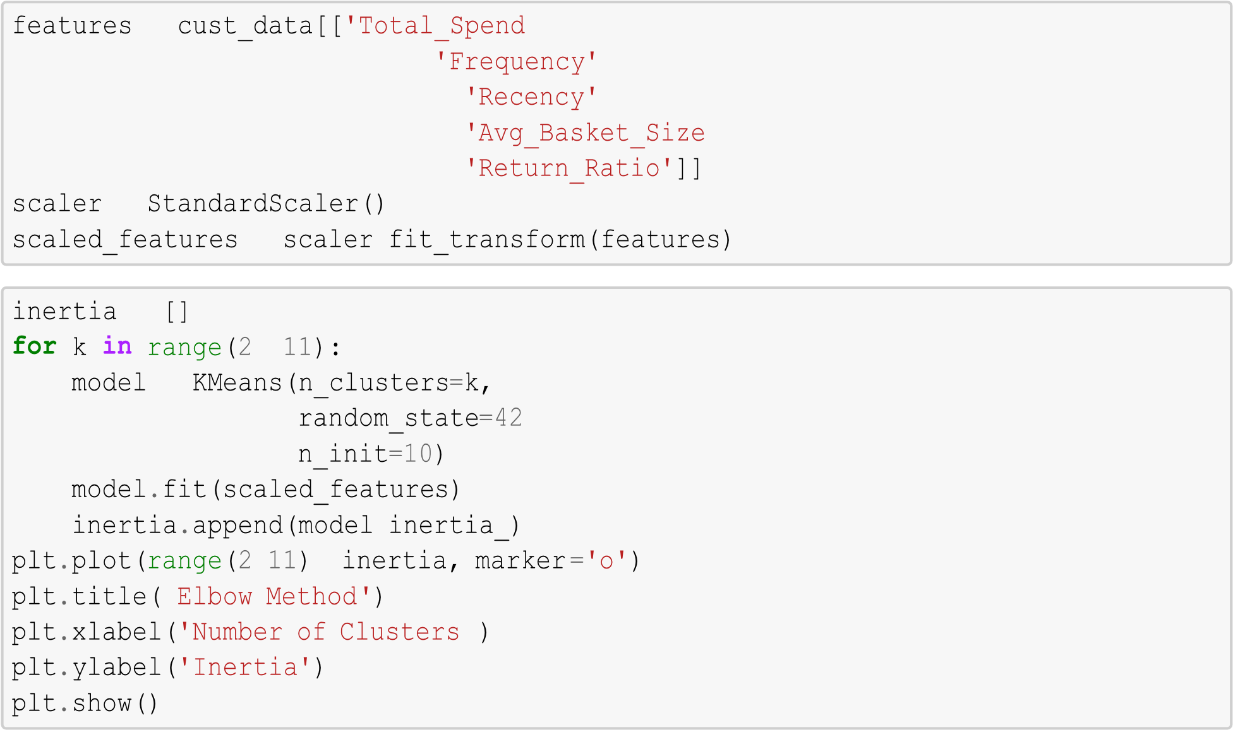
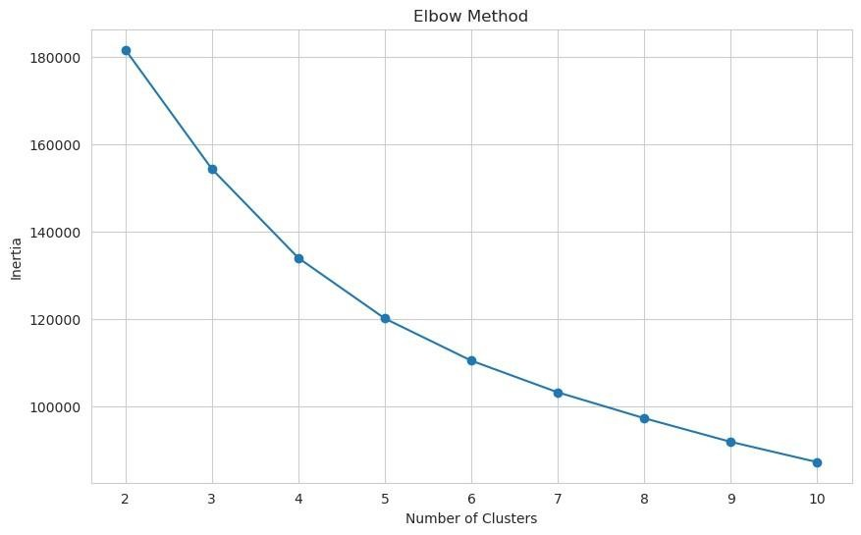
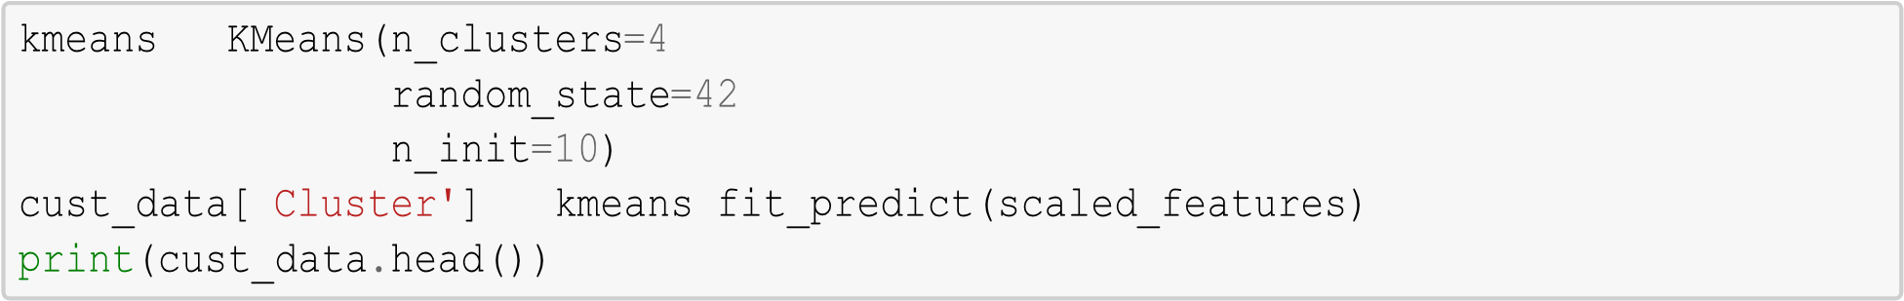
Customer ID Total_Spend Frequency Recency Avg_Basket_Size \ 0 1 3491 1 57 5.000000
- 2 7988 3 298 2.666667
- 3 22587 8 88 2.875000
- 4 8715 4 126 2.250000
- 5 12524 8 170 4.125000
Return_Ratio Churn Cluster
- 1.000000 0 3
- 0.333333 0 2
- 0.375000 0 1
- 0.250000 1 2
- 0.500000 0 1
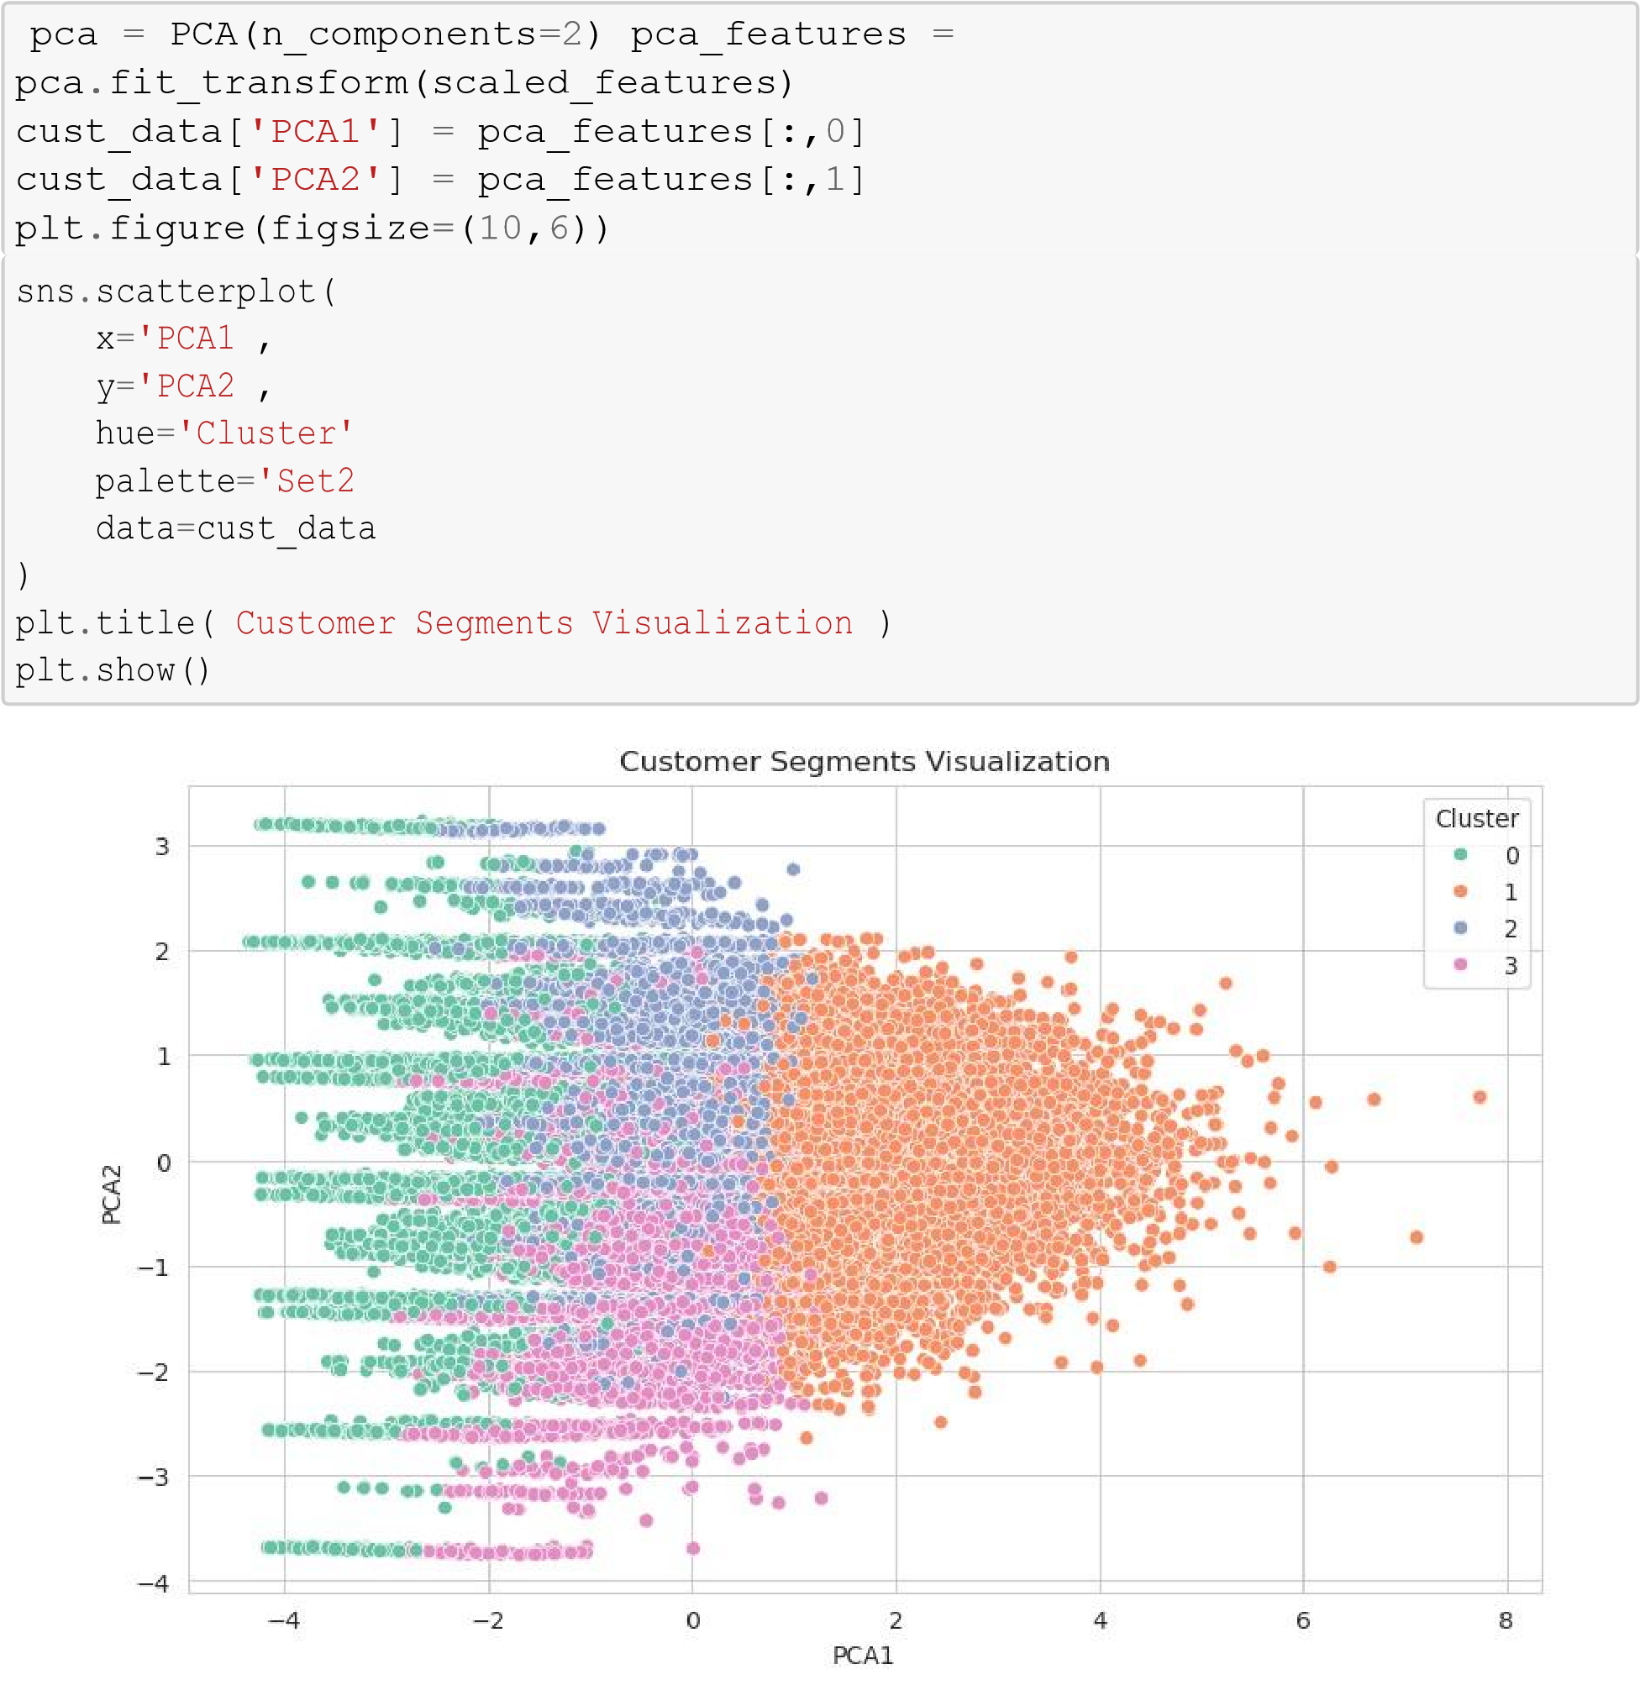


Customer ID Total_Spend Frequency Recency Avg_Basket_Size \
Cluster
    - 24806.836802 7439.773454 2.833183 743.483258
3.045852
    - 25013.461270 21660.052801 7.596623 151.254154 2.997528
    - 25020.569355 11300.833270 4.320147 195.027450 2.991739
    - 25025.640178 10571.325476 4.025759 216.534305 2.989812
Return_Ratio Churn PCA1 PCA2
Cluster
0 0.352371 0.199849 -2.075122 0.161159 1 0.410957 0.198271 1.673189 0.011726
    - 0.209741 0.197667 -0.330303 0.434749
    - 0.661758 0.205751 -0.486221 -0.656235
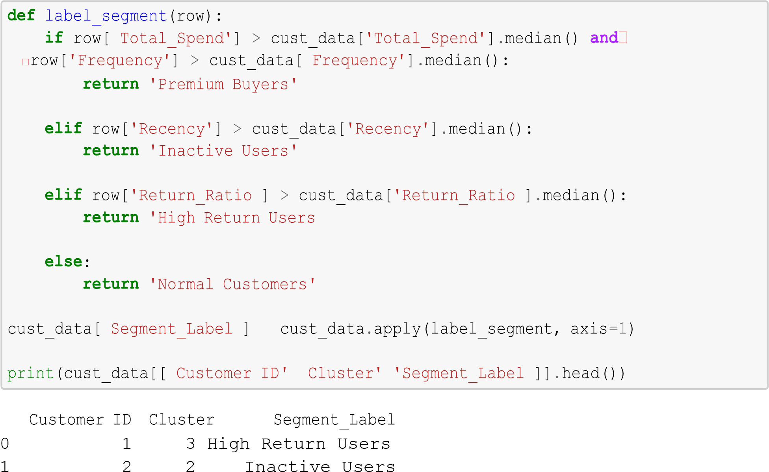
2 3 1 Premium Buyers
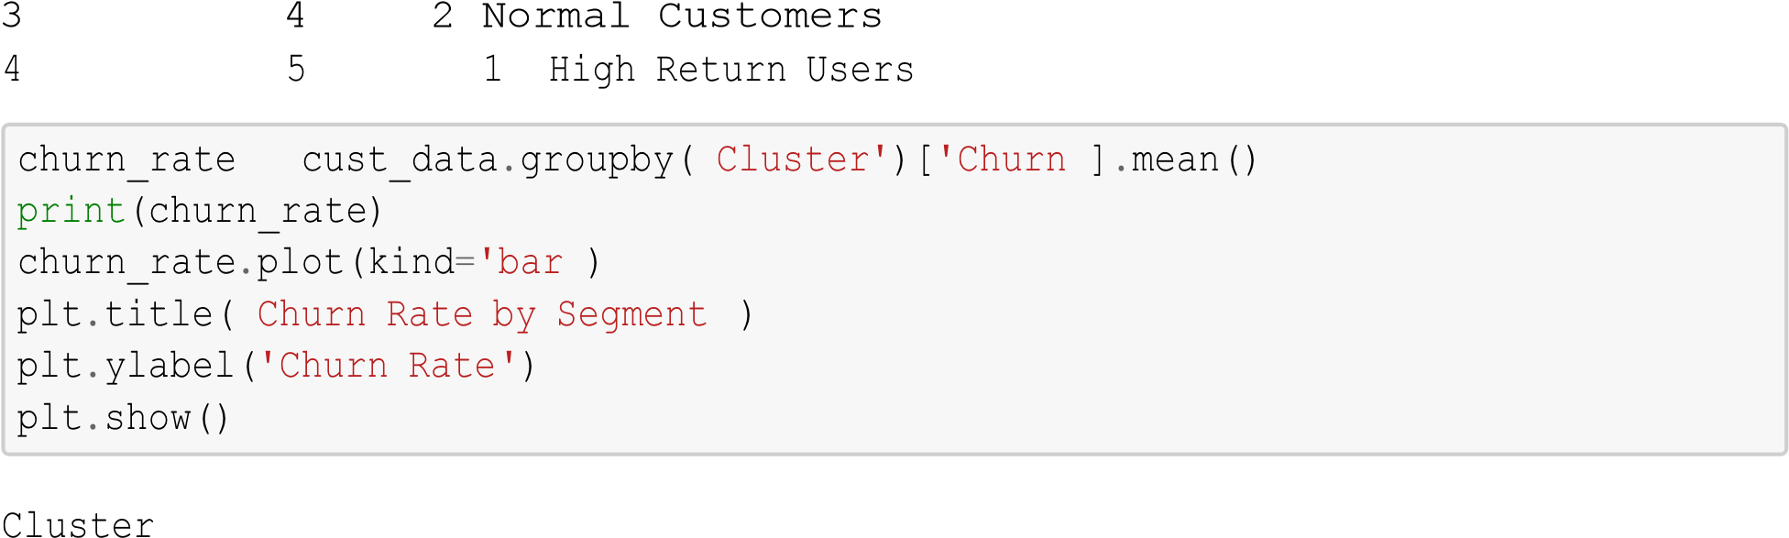
0
0.199849 1
0.198271 2
0.197667
3 0.205751
Name: Churn, dtype: float64
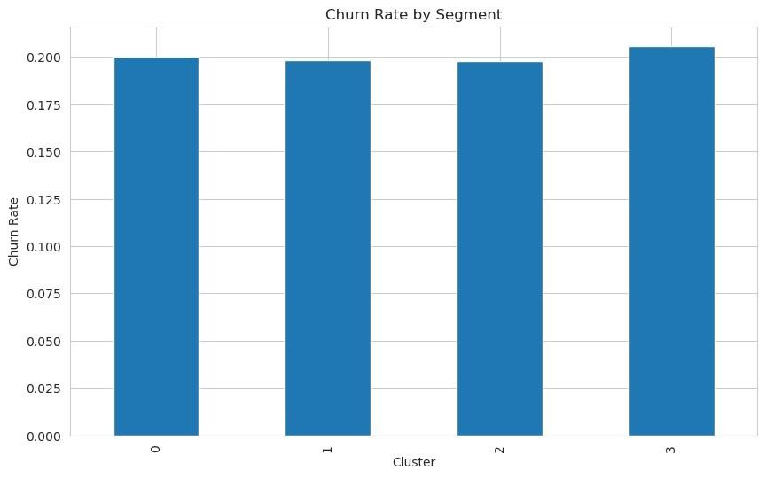
top_customers = cust_data.sort_values(by='Total_Spend',
ascending=False).
↪
head(
10
)

print
(
top_customers
[[
'Customer
ID'
,
'Total_Spend'
]])

Customer ID Total_Spend
36211 36437 55339
39561 39817 51718
26818 26977 48497
5809 5844 46541
3555 3576 46518
13718 13802 46464
802 809 45738
46785 47087 45700
14313 14400 45334
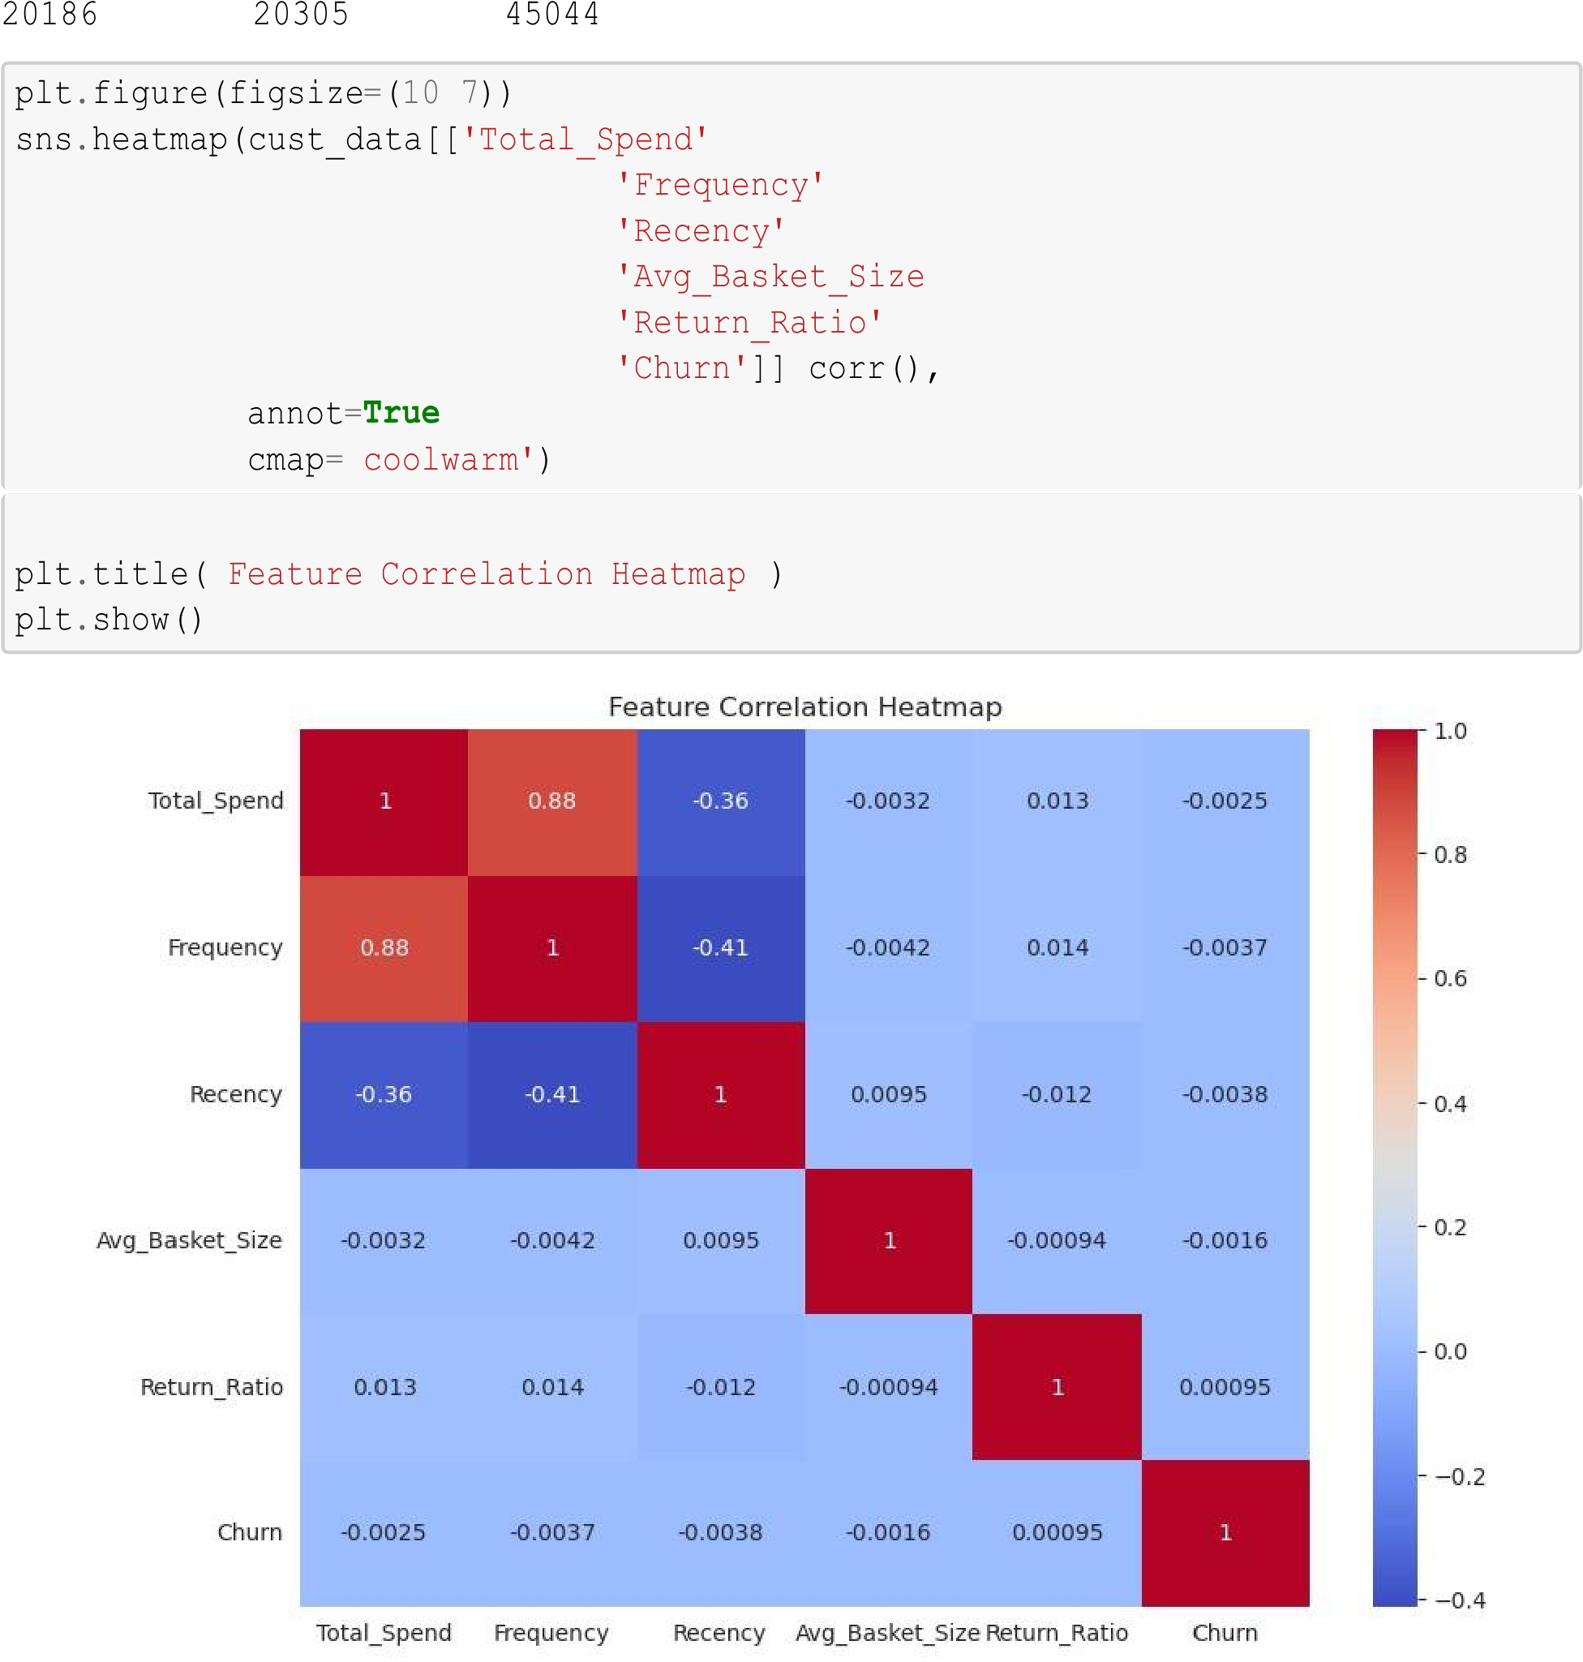
cust_data.to_csv('customer_segments_output.csv', index=False) print('Customer segmentation file saved successfully!') Customer segmentation file saved successfully!
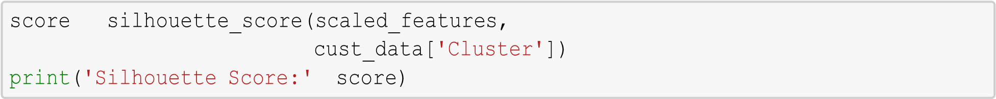

Silhouette Score: 0.21081061022991684

Jupyter notebook link:
https://anaconda.com/app/share/notebooks/71efe0a1-01d9-4998-aafc-bfbf97d68474/overview

Final Executive Summary
This analysis delivers a comprehensive evaluation of customer behavior using transactional data. The objective was to extract meaningful, data-driven insights into customer segmentation, purchasing dynamics, retention patterns, and churn propensity.
By applying robust data preprocessing, feature enrichment, and clustering techniques, customers were stratified into distinct behavioral cohorts such as HighValue Customers, Dormant Users, and Return-Intensive Buyers. This segmentation framework enabled a deeper understanding of customer lifetime value, engagement intensity, and risk profiles.
Key findings indicate that loyal, high-frequency customers contribute disproportionately to overall revenue, whereas segments exhibiting inactivity or elevated return behavior signal potential disengagement and churn risk. Furthermore, analysis of purchasing trends across product categories, payment modes, and time periods uncovered critical behavioral shifts and seasonal patterns.

Actionable Insights for Enhanced Engagement

1. Precision-Driven Personalization
Deploy AI-powered recommendation systems to deliver tailored product suggestions based on individual purchase history and browsing behavior, thereby increasing conversion rates and customer satisfaction.

2. Tiered Loyalty Ecosystem
Introduce a multi-level rewards program that incentivizes repeat purchases, offering exclusive benefits, early access, and personalized perks to high-value customers.

3. Reactivation Campaigns for Dormant Users
Implement targeted re-engagement strategies such as limited-time discounts, personalized emails, and reminders to revive inactive customers and restore engagement.

4. Return Behavior Optimization
Analyze return patterns to identify root causes (e.g., product mismatch, quality concerns) and implement corrective measures such as improved product descriptions, size guides, or quality assurance.

5. Dynamic Engagement Through Behavioral Triggers
Leverage real-time analytics to initiate automated triggers (e.g., abandoned cart alerts, milestone rewards, timely notifications) that enhance customer interaction and reduce drop-offs.

Conclusion
This analytical study provides a strategic foundation for transitioning from reactive decision-making to proactive, insight-driven customer engagement. By implementing these recommendations, organizations can strengthen customer relationships, minimize churn, and accelerate sustainable growth in a competitive marketplace.

